Robert LLyod S. Baban BSSE-2

DATABASE

Part 1 Conceptual Design

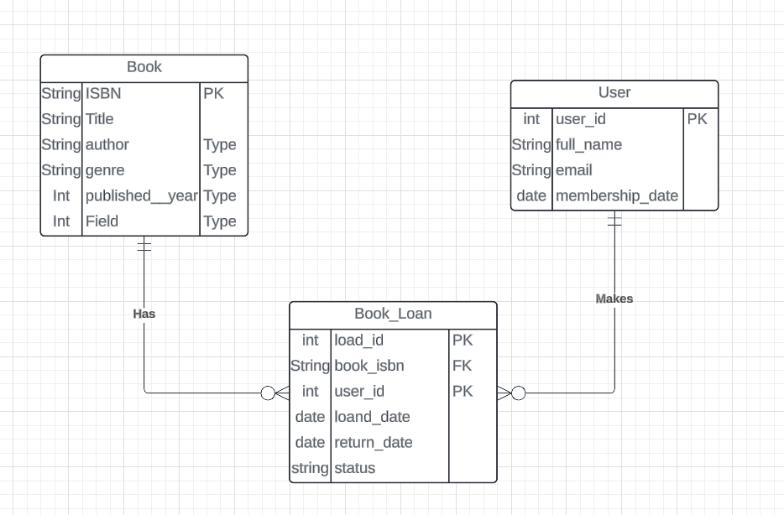

Part 2: Logical Design:

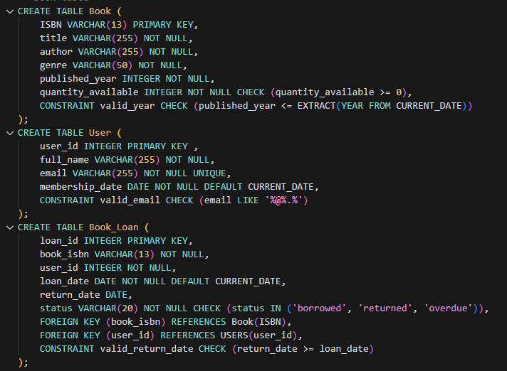

3.

a.. Insert a new book into the library with a quantity of 5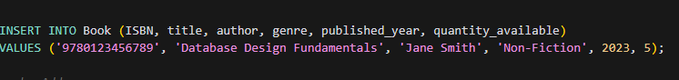

B.Add a newuser to the system.

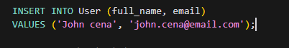

C..Record a book loan for a user.

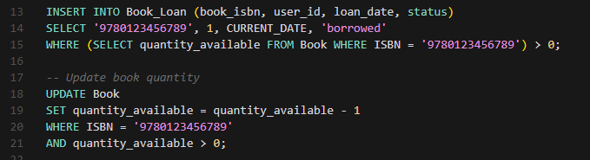

D.Find all books borrowed by a specific user

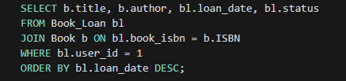

E..List all overdue loans.

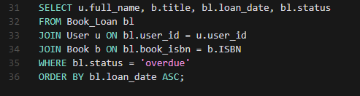

Part 4: Data Integrity and Optimization

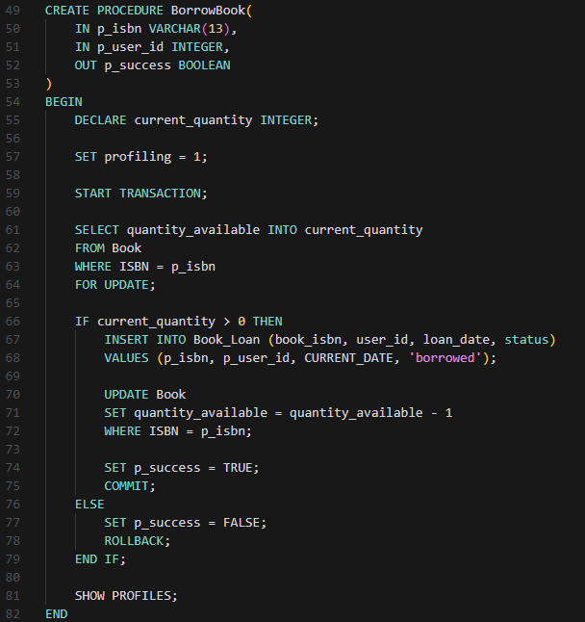

Part 5: Reflection

Potential challenges when scaling to millions of users and books:

1. Performance Challenges:
   * Solution: Implement database partitioning by date ranges or geographic regions
2. Data Consistency:
   * Solution: Implement eventual consistency for non-critical operations
3. Storage Requirements:
   * Solution: Implement data archiving for old records
4. Query Performance:
   * Solution: Implement read replicas
5. Concurrent Access:
   * Solution: Implement connection pooling